Measures of central tendency for grouped data
Definition of term
- Data are individual pieces of factual information recorded and used for the purpose of analysis.
- Ungrouped data is the data you first gather from an experiment or study (raw) that is not sorted into categories, classified, or otherwise grouped.
- Grouped data is the data formed by aggregating individual observations of a variable into groups, so that a frequency distribution of these groups serves as a convenient means of summarizing or analyzing the data.
- Frequency is the number of occurrences a repeating data point occurs.
- Frequency distribution is a list, table or graph that displays the frequency of various outcomes in a sample
- Cumulative frequency is calculated by adding each frequency from frequency distribution table to the sum of its predecessors.
- Relative frequency is the frequency of a data point expressed as a percentage of the total number of data set.
- Relative cumulative frequency can be found by dividing the frequency of each interval by the total number of observations.
- Class limits are the smallest and largest observations (data) in each class.
- Upper class limit of a class is the largest data value that can go into the class.
- Lower class limit of a class is the least data value that can go in a class
- Class width refers to the difference between the upper and lower boundaries of any class also known as class interval
- Class boundary is the midpoint of the upper-class limit of one class and the lower-class limit of the subsequent class.
- Midpoint (or “class mark”) of each class can be calculated as: Midpoint = Lower class limit + Upper class limit divided by 2

Grouped data
- Data is often described as ungrouped or grouped. Ungrouped data is data given as individual data points.
- Grouped data refers to data formed by arranging individual observations of a variable into groups, so that a frequency distribution table of these groups provides a convenient way of summarizing or analyzing the data.
- Grouped data also refers to data given in the form of class intervals.
- Grouping of data plays a significant role when we have to deal with large data.
- It requires creation of frequency distribution table in interval
- It can also be presented in histograms

Guidelines for classes
- There should be between 5 and 20 classes.
- The class width should be an odd number. This will guarantee that the class midpoints are integers instead of decimals.
- The classes must be mutually exclusive. This means that no data value can fall into two different classes
- The classes must be all inclusive or exhaustive. This means that all data values must be included.
- The classes must be continuous. There are no gaps in a frequency distribution. Classes that have no values in them must be included (unless it's the first or last class which are dropped).
- The classes must be equal in width. The exception here is the first or last class. It is possible to have an "below ..." or "... and above" class. This is often used with ages.

Creating a Grouped Frequency Distribution
- Find the largest and smallest values
- Compute the Range = Maximum - Minimum
- Select the number of classes desired. This is usually between 5 and 20.
- Find the class width by dividing the range by the number of classes and rounding up. There are two things to be careful of here. You must round up, not off. Normally 3.2 would round to be 3, but in rounding up, it becomes 4. If the range divided by the number of classes gives an integer value (no remainder), then you can either add one to the number of classes or add one to the class width. Sometimes you're locked into a certain number of classes because of the instructions.
- Pick a suitable starting point less than or equal to the minimum value. You will be able to cover: "the class width times the number of classes" values. You need to cover one more value than the range. Follow this rule and you'll be okay: The starting point plus the number of classes times the class width must be greater than the maximum value. Your starting point is the lower limit of the first class. Continue to add the class width to this lower limit to get the rest of the lower limits.
- To find the upper limit of the first class, subtract one from the lower limit of the second class. Then continue to add the class width to this upper limit to find the rest of the upper limits.
- Find the boundaries by subtracting 0.5 units from the lower limits and adding 0.5 units from the upper limits. The boundaries are also half-way between the upper limit of one class and the lower limit of the next class. Depending on what you're trying to accomplish, it may not be necessary to find the boundaries.
- Tally the data.
- Find the frequencies.
- Find the cumulative frequencies. Depending on what you're trying to accomplish, it may not be necessary to find the cumulative frequencies.
- If necessary, find the relative frequencies and/or relative cumulative frequencies.

Example: Consider the following ages of students 57, 65, 60, 51, 55, 59, 65, 60, 58, 58, 60, 58kgs

- Highest value = 65
- Least value = 51
- Difference between the highest and lowest = 65-51 = 14
- Number of classes we need = 5
- Class interval = 14/5 =2.8, round up to whole number = 3
- Draw your frequency distribution table with class interval of 3 and 5 classes as shown below
Frequency distribution table
Class limits (age years) | Tally | Frequency
51-53 | / | 1
54-56 | / | 1
57-59 | ///// | 5
60-62 | /// | 3
63-65 | // | 2

Measures of central tendency for grouped data
Some of the measures of central tendency that are applied in grouped data include mean, media and mode.

Mean, median and mode of grouped data
- For grouped data, we cannot find the exact Mean, Median and Mode, we can only give estimates.

Estimation of mean of grouped data
Using a grouped data, the sample and population means can be calculated using the following equation below.

Formula to estimate sample mean for grouped data
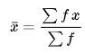

Where;
Σ = sum of
f = frequency

Formula to estimate population mean of grouped data

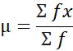
Where:
Σ = sum of
f = frequency

Calculation of mean of grouped data
- The first step is to determine the midpoint (also called a class mark) of each interval, or class.
- These midpoints must then be multiplied by the frequencies of the corresponding classes.
- The sum of the products divided by the total number of values will be the value of the mean.

Example
The data below represent the ages of patients diagnosed with diabetes in Mbagathi County Hospital on February 10th, 2023. Create a frequency distribution table and calculate the estimated mean age of the grouped data.
20 | 34 | 26 | 25 | 19 | 72 | 18 | 45 | 40 | 32 | 26 | 11 | 55 | 54 | 60 | 45 | 39 | 59 | 74 | 79
- Highest value = 79
- Least value = 11
- Difference between the highest and lowest = 79-11 = 68
- Number of classes we need = 7
- Class interval/ class width = 68/7 = 9.71, round up to whole number = 10
- Draw your frequency distribution table with class interval of 10 and 7 classes as shown below
Frequency distribution table
Class interval | Tally | Frequency (f)
10-19 | /// | 3
20-29 | //// | 4
30-39 | /// | 3
40-49 | /// | 3
50-59 | /// | 3
60-69 | / | 1
70-79 | /// | 3
Σ |  | 20

After creating a frequency distribution table, calculate the midpoint (x) by adding the lower class limit and higher class limit of each class/group and then divide by two. Multiply frequency (f) and midpoint (x) of each class/group to obtain value of fx and sum them (Σfx). Also calculate the sum of the frequency (Σf).
Class interval | Tally | Frequency (f) | Mid-point (x) | fx
10-19 | /// | 3 | 14.5 | 43.5
20-29 | //// | 4 | 24.5 | 98
30-39 | /// | 3 | 34.5 | 103.5
40-49 | /// | 3 | 44.5 | 133.5
50-59 | /// | 3 | 54.5 | 163.5
60-69 | / | 1 | 64.5 | 64.5
70-79 | /// | 3 | 74.5 | 223.5
Σ |  | 20 |  | 830

Using the formula to calculate sample mean of grouped data. Calculate the mean.
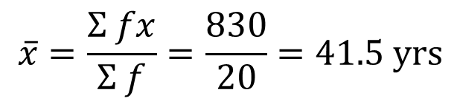

Estimation of median of a grouped data
The median of a grouped data is estimated using the formula below
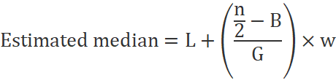
Where:
L is the lower-class boundary of the class/group containing the median
n is the total number of values
B is the cumulative frequency of the class/groups before the median group
G is the frequency of the median class/group
w is the class/group width
Lower class boundary of the class/group containing the median is calculated by adding lower class limit of median group with upper class limit of group before the median group and then divide the value by two.
Upper class boundary of a given class is obtained by averaging the upper limit of the class and the lower limit of the next class.
Cumulative frequency is calculated by adding each frequency from a frequency distribution table to the sum of its predecessors.

Calculation of median of grouped data
Example
The frequency distribution table below represent the ages of patients diagnosed with diabetes in Mbagathi County Hospital on February 10th, 2023. Calculate the estimated median.
Class interval | Tally | Frequency (f)
10-19 | /// | 3
20-29 | //// | 4
30-39 | /// | 3
40-49 | /// | 3
50-59 | /// | 3
60-69 | / | 1
70-79 | /// | 3
Σ |  | 20

- First calculate the cumulative frequency
Class interval | Frequency (f) | Cumulative frequency
10-19 | 3 | 3
20-29 | 4 | 7
30-39 | 3 | 10
40-49 | 3 | 13
50-59 | 3 | 16
60-69 | 1 | 17
70-79 | 3 | 20

- The median is the middle value, which in our case is the 11th one, which is in the 40-49 group: We can say "the median group is 40-49"
- But if we want an estimated Median value we need to look more closely at the 40-49 group.

L = 39.5
n = 20
B = 10
G = 3
W =10
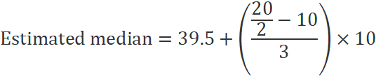

Estimation of mode of grouped data
The mode is the data point which occurs most frequently.
Mode of a grouped can be estimated using the following formula:
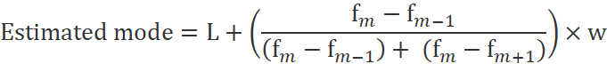
where:
L is the lower class boundary of the modal class/group
f_{m-1} is the frequency of the group before the modal class/group
f_{m} is the frequency of the modal class/group
f_{m+1} is the frequency of the group after the modal class/group
w is the group width

Calculation of mode of grouped data
Example:
The frequency distribution table below represent the ages of patients diagnosed with diabetes in Mbagathi County Hospital on February 10th, 2023. Calculate the estimated median.
Class interval | Tally | Frequency (f)
10-19 | /// | 3
20-29 | //// | 4
30-39 | /// | 3
40-49 | /// | 3
50-59 | /// | 3
60-69 | / | 1
70-79 | /// | 3
Σ |  | 20

We can easily find the modal group (the group with the highest frequency), which is 20-29

We can say "the modal group is 20-29"

But the actual Mode may not even be in that group! Without the raw data we don't really know.

L = 19.5
f_{m-1} = 3
f_{m} = 4
f_{m+1} =3
w = 10

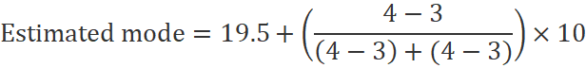

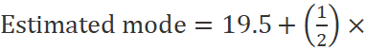10

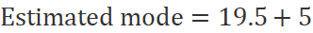

Estimated mean, median and mode = 41.5, 39.5 and 24.5 years respectively

Ungrouped mean, mode and median
True mean = 20 + 34 + 26 + 25 + 19 + 72+ 18+ 45 + 40 + 32 + 26 + 11 + 55+ 54 + 60 + 45 + 39 + 59 + 74 + 79 = 833/20 = 41.65 years
Mode = 26 and 45
Median = 11, 18, 19, 20, 25, 26, 26, 32, 34, 39, 40, 45, 45, 54, 55, 59, 60, 72, 74, 79
(n+1)1/2 = (20+1)1/2 =21/2= 10.5th = 39 + 40= 79/2 = 39.5 years

The mean and mode of ungrouped data was close those of estimated mean and median. However, the mode for ungrouped data was bimodal

Types of means
In measures of the central tendency there are three types of means
- Arithmetic mean
- Harmonic mean
- Geometric mean
- Weighted mean

Arithmetic mean
Arithmetic mean is same as the average of data
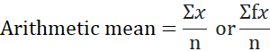

Harmonic mean
Harmonic mean is the harmonic mean is the reciprocal of the arithmetic mean of the reciprocals. A harmonic mean is used in averaging of ratios.
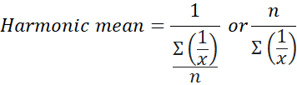
For example, to calculate the harmonic mean of 2, 4, 4, and 3, you would divide the number of observations by the reciprocal of each number, as follows:
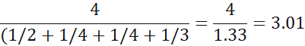

Geometric mean
Geometric mean it is defined as the arithmetic mean of the values taken on a log scale. It is also expressed as the n^{th} root of the product of an observation. The geometric mean for the given data set is always less than the arithmetic mean for the data set. It is used in skewed data.
For example, consider the given data set, 4, 10, 16, 24
Here n= 4

Therefore, the geometric mean = 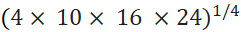 =15360^1/4 = 11.13

or 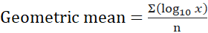
get log₁₀ of all data points, add them together and then divide by n

Log₁₀(4 + 10 + 16 + 24)/4 = (0.6021 + 1.00 + 1.2041 + 1.380)/4 =4.1862/4 = 1.04655
Antilog 1.04655 = 10^1.045 = 11.13

Weighted mean
Weighted mean is a type of mean that is calculated by multiplying the weight (or probability) associated with a particular event or outcome with its associated quantitative outcome and then summing all the products together.

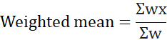

Where: x = data values and w = weights applied to x values

It is very useful when calculating a theoretically expected outcome where each outcome has a different probability of occurring. For example, a student may use a weighted mean in order to calculate his/her percentage grade in a course.

Item | Weight | Grade | Weight x grade
Assignment 1 | 10% | 70% | 700
Assignment 2 | 10% | 65% | 650
Mid-term exam | 30% | 70% | 2100
Final exam | 50% | 85% | 4250
 | Σ = 100 |  | Σ = 7700

Weighted mean = 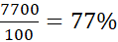

Measures of Dispersion
Definition of terms
- Dispersion is the state of getting dispersed or spread.
- Statistical dispersion means the extent to which a numerical data is likely to vary about an average value.
- Data distribution is a function or a listing which shows all the possible values (or intervals) of the data
- Measure of dispersion are measures that shows how squeezed or scattered a variable is or measures that help to understand the distribution of a data
- Range it is the difference between the maximum value and the minimum value given in a data set.
- Variance is the average squared deviations from the mean in a data set
- Standard Deviation: The square root of the variance
- Quartiles are values that divide a list of numbers into quarters.
- Percentile (or a centile) is a measure indicating the value below which a given percentage of observations in a group of observations fall.
- Deciles is subdivision of a data set into ten equal parts
- Skewness is a measure of distortion or asymmetry that deviates from the symmetrical bell curve, or normal distribution, in a set of data.
- Change of origin refers to addition or subtraction of a values to a data set.
- Change of scale refers to multiplication or division of a value to a data set.

Measure of dispersion
- Measure of dispersion is a measure that describe the variation or scattering of a set of data and gives a clear idea about the distribution (spread) of the data.
- The measure of dispersion shows the homogeneity or the heterogeneity of the distribution of the observations.
- The measures of central tendency do not tell how a data set is distributed. The measures of dispersion help us to know about the spread of a data.
- The measures of central tendency are used together with measures of dispersion to provide an overall description of a set of data.
- A measure of spread gives us an idea of how well the mean, for example, represents the data. If the spread of values in the data set is large, the mean is not as representative of the data. This is because a large spread indicates that there are probably large differences between individual scores (outliers).
- For example, in the figure below, data set A shows that the data points (values) are close to the mean, followed by data set B, while data C values are far away from the mean.

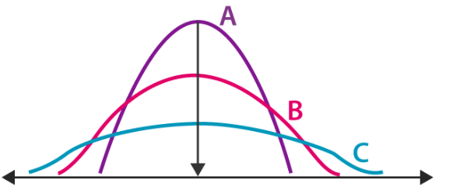
Diagram of Measure of dispersion

Sources/types of variability in data
In any data, there can occur three kinds of variability:
- Biological
- Real
- Experimental.

Biological Variability
As the name suggests, biological variability is related to the human body and medications. In the same environment and test conditions two individuals can respond differently when compared to each other. These variations may arise due to difference in sex class, weight etc. Such variations are also known as biological variability.
Real Variability
Real variability is also known as variability within the limits. The variability is termed as real when the difference between two readings or observations is more than the defined limits of the universe.

Experiment Variability
Experimental variability occurs during the time of experiments. It may arise because of error or difference during methods, procedure or any other defects during the techniques. Experimental variability is further classified into three types:
- Observer error
- Instrumental error
- Sampling error.
Observer error: Observer error can be subjective or objective. For subjective error consider the way an interviewer may change the information while asking the questions and objective error occurs when an untrained observer records the measurement.

Instrumental error: Instrumental error is generally negligible and gross. It is caused because of defects in machines, height measures, calibration errors and other undesirable variability that is responsible for wrong conclusions or calculation.
Sampling error: Sometimes, biased samples are also responsible for different variations. A sample drawn shouldn't be too small to draw decisions else it may again result in variations.

Good characteristics of Measures of Dispersion
- A measure of dispersion should be rigidly defined
- It must be easy to calculate and understand
- It should not be affected by sampling fluctuations.
- Based on all observations
- It should not be affected by extreme values.
- It should be capable of further mathematical treatment and statistical analysis.

What are the objectives of computing dispersion?
- Comparative study
Measures of dispersion give a single value indicating the degree of consistency or uniformity of distribution. This single value helps us in making comparisons of various distributions.
The smaller the magnitude (value) of dispersion, higher is the consistency or uniformity and vice-versa.
- Reliability of an average
A small value of dispersion means low variation between observations and average. It means that the average is a good representative of observation and very reliable.
A higher value of dispersion means greater deviation among the observations. In this case, the average is not a good representative and it cannot be considered reliable.
- Control the variability
Different measures of dispersion provide us data of variability from different angles, and this knowledge can prove helpful in controlling the variation.
- Basis for further statistical analysis
Measures of dispersion provide the basis for further statistical analysis like computing correlation, regression, test of hypothesis, etc.

Applications of Measures of Dispersion
- A measure of spread also called a measure of dispersion, is used to describe the variability in a sample or population.
- Measures of Dispersion are used to estimate “normal” values of a dataset, measures of dispersion are important for describing the spread of the data, or its variation around a central value.
- It is usually used in conjunction with a measure of central tendencies, such as the mean or median, to provide an overall description of a set of data.

Types of Measures of Dispersion
There are two main types of dispersion methods in statistics which are:
- Absolute Measure of Dispersion
Absolute measures of dispersion are expressed in the unit of variable itself
- Relative Measure of Dispersion
Also known as coefficients of dispersion. They are obtained as ratios or percentages of the average.

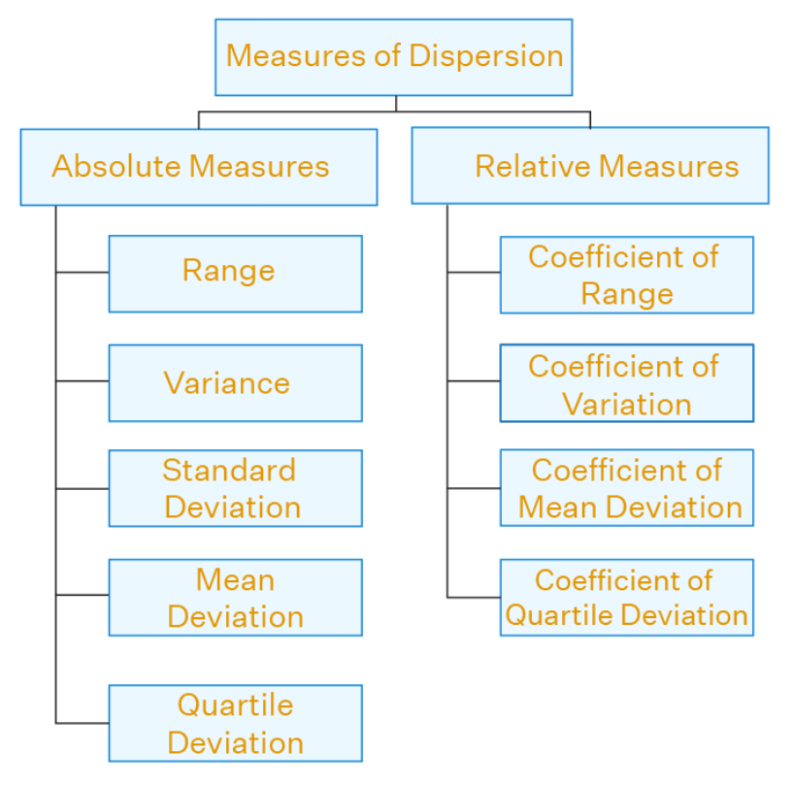

- Absolute Measure of Dispersion
An absolute measure of dispersion contains the same unit as the original data set. They are measures which express the scattering of observation in terms of distances i.e., range, quartile deviation or measures which expresses the variations in terms of the average of deviations of observations like standard or means deviations.
They include:
- Range
- Quartiles and interquartile range
- Quartile deviation or semi-interquartile range
- Absolute deviation and mean absolute deviation
- Variance
- Standard deviation

- Range
The range is the difference between the highest and lowest scores in a data set. It is the simplest measure of spread.

Range = maximum value - minimum value

For example, the data set below represent normal body temperature (ºC) of 10 individuals.
37.4 | 37.2 | 36.5 | 37.1 | 36.6 | 36.8 | 36.5 | 37.5 | 37.4 | 37.4
Calculate the range.
Steps to calculate range:
- Order the numbers in your data set from lowest to highest
  - 36.5, 36.5, 36.6, 36.8, 37.1, 37.2, 37.4, 37.4, 37.4, 37.5

- Locate the smallest and largest numbers, then subtract
  - Range = Maximum value – minimum value
  - Range = 37.5-36.5 = 1ºC

Whilst using the range as a measure of spread is limited, it does set the boundaries of the scores. Range can be useful if you are measuring a variable that has either a critical low or high threshold (or both) that should not be crossed e.g. normal body temperature (36.5-37.5ºC), normal blood pressure 90/60mmHg and 120/80mmHg. The range will instantly inform you whether at least one value broke these critical thresholds. The range can also be used to detect any errors when entering data.

Merits of Range
- It is the simplest of the measure of dispersion
- Easy to calculate
- Easy to understand
- Independent change of origin
Demerits of Range
- It is based on two extreme observations. Hence, get affected by fluctuations
- A range is not a reliable measure of dispersion
- Dependent on change of scale

- Quartiles and Interquartile Range
Quartiles are values that divide a data set into quarters
- The first quartile (Q₁) or lower quartile is the value in the middle of the first term and the median or the value below which 25% of the distribution lies.
- The second quartile (Q₂) or middle quartile is the median or the value below which 50% of the distribution lies
- The third quartile (Q₃) or upper quartile is the middle value between the median and the last term or the value below which 75% of the distribution lies

When calculating the quartiles, the following should be done:
- Put the list of numbers ascending order
- Then cut the list into four equal parts
- The quartiles are at the "cuts“

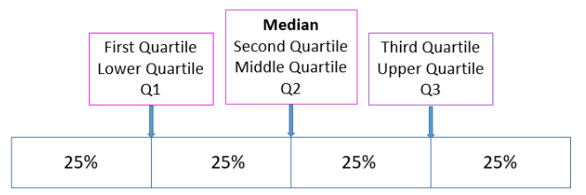
Diagram of quartile

Example: Calculate the quartiles of the following data

5, 7, 4, 4, 6, 2, 8

- Arrange in ascending order

2, 4, 4, 5, 6, 7, 8

- Cut it into four equal parts (quartiles)

The quartiles can be calculated with the following formula
- First Quartile (Q₁) = ((n+1)/4) th Term also known as the lower quartile or 25th percentile.
- The second quartile or the 50th percentile or the Median is given as: Second Quartile(Q₂) = ((n+1)/2) th Term
- The third Quartile of the 75th Percentile (Q₃) is given as: Third Quartile (Q3) = (3(n+1)/4) th Term also known as the upper quartile.

Calculation
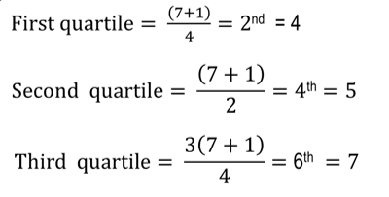
If the quartile th number is between two numbers in data digits in your data set, add the two data digit and then divide by two.

Interquartile range
Interquartile range (IQR) is the range from the 25th percentile to the 75th percentile. It is calculated as: Upper Quartile – Lower Quartile
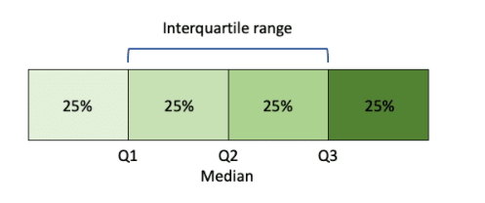

Steps in calculation of interquartile range
- Order the data from least to greatest.
- Find the median.
- Calculate the lower and upper quartile of the data.
- The IQR is the difference between the upper and lower medians.

Example: Find the median, lower quartile, upper quartile and interquartile range of the following data set of values: 19, 21, 23, 20, 23, 27, 25, 24, 31

Solution:
Firstly arrange the values in ascending order.
19, 20, 21, 23, 23, 24, 25, 27, 31

Plug in the values in the formulas we get,
Median (Q₂) = (9+1)/2 = 5th Term=23
Lower Quartile (Q₁) = (9+1)/4 = 2.5th Term = 20+21/2 = 20.5
Upper Quartile (Q₃) = 3(10+1)/4 = 7.5th Term = (25+27)/2 = 26

IQR=Upper Quartile−Lower Quartile

IQR = 26 – 20.5
IQR = 5.5

Box and Whisker Plot
A box and whisker plot also called a box plot displays the five number summary of a set of data. The five number summary is the minimum value, first quartile, median, third quartile, and maximum value.
In a box plot, we draw a box from the first quartile to the third quartile. A vertical line goes through the box at the median. The whiskers go from each quartile to the minimum or maximum value.

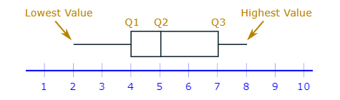

Box and whisker plots are very effective and easy to read, as they can summarize data from multiple sources and display the results in a single graph.

Advantages of IQR
- Able to identify and eliminate outliers on both ends of a data set.
- Good measure of variation in cases of skewed data distribution
Disadvantages IQR
- Less sensitivity to a few extreme scores compared to standard deviation
- Sampling stability that is not as strong as standard deviation.
- They do not take into account every score in the data set

- Semi-interquartile range/Quartile deviation
The semi-interquartile range (SIR) (also called the quartile deviation) is a measure of spread that how data is dispersed around a central point (usually the mean).

How to Calculate the Semi Interquartile Range / Quartile Deviation
As the SIR is half of the Interquartile Range, all you need to do is find the IQR and then divide your answer by 2

How to calculate semi-interquartile range
Step 1: Find the first quartile, Q₁.
Step 2: Find the third quartile, Q₃.
Step 3: Subtract Q₃ from Q₁.
Step 4: Then, divide by 2.

Example
Question: Find the Quartile Deviation for the following set of data:
{490, 540, 590, 600, 620, 650, 680, 770, 830, 840, 890, 900}

Step 1: Find the first quartile, Q₁.
This is the median of the lower half of the set {490, 540, 590, 600, 620, 650}.
Q1 = (590 + 600) / 2 = 595.

Step 2: Find the third quartile, Q₃.
This is the median of the upper half of the set {680, 770, 830, 840, 890, 900}.
Q3 = (830 + 840) / 2 = 835.

Step 3: Subtract Q₃ from Q₁.
835 – 595 = 240.

Step 4: Divide by 2. 240 / 2 = 120

The SIR/quartile deviation for this set of data is 12.

Merits of Quartile Deviation
- All the drawbacks of Range are overcome by quartile deviation
- It uses half of the data
- Independent of change of origin
Demerits of Quartile Deviation
- It ignores 50% of the data
- Dependent on change of scale
- Not a reliable measure of dispersion

